Contributors
- Şevda Yağmur Asal
- Oğuz Giray Bori
- Deren Berk
- Mert Dönmez

1. System Overview
Brief Project Description
Dizi Kutusu is a web-based series tracking and review platform. Users can register, log in, search for TV series, rate them, write reviews, and maintain a personal watchlist. The main goal is to provide a structured environment where users can manage and share their viewing experiences.
System Architecture
The system follows a Layered Architecture:
- Presentation Layer (Frontend – HTML/CSS/JS)
- Application Layer (Flask routes & services)
- Data Layer (SQLite + SQLAlchemy)
Architecture Type:
Monolithic modular backend with separated components.
Technology Stack
Frontend:
- HTML
- CSS
- JavaScript
Backend:
- Python
- Flask
- SQLAlchemy

Database:
- SQLite
Testing:
- Pytest
Version Control:
- GitHub
2. Implementation Details
Codebase Structure
dizi_kutusu/
│
├── app/
│ ├── routes/
│ ├── models/
│ ├── services/
│ ├── auth/
│ ├── templates/
│ └── static/
│
├── tests/
├── config.py
├── run.py
└── requirements.txt
Key Implementations
1. Authentication Module
Handles:
- User registration
- Login
- Logout

2. Series Module
Handles:
- Add series
- Search series
- View details
3. Rating & Review Module
Handles:
- Add rating (1–10)
- Add review
- Calculate average rating

Component Interfaces
Example Model
class User(db.Model):
id = db.Column(db.Integer, primary_key=True)
username = db.Column(db.String(50))
email = db.Column(db.String(100))
password_hash = db.Column(db.String(200))

Auth Component
Input:
- email (string)
- password (string)
Output:
- success (boolean)
- session object

Series Component
Input:
- title (string)
- genre (string)
- description (string)
Output:
- series object
- success status
Review Component
Input:
- rating (integer 1–10)
- review_text (string)
Output:
- updated average rating
- success status

Example API Endpoints
Method | Endpoint | Description
POST | /register | Register user
POST | /login | Login user
GET | /series | List or search series
GET | /series/<id> | View series details
POST | /series | Add new series
POST | /series/<id>/rate | Add rating
POST | /series/<id>/review | Add review

Visual Interfaces
- Login Page
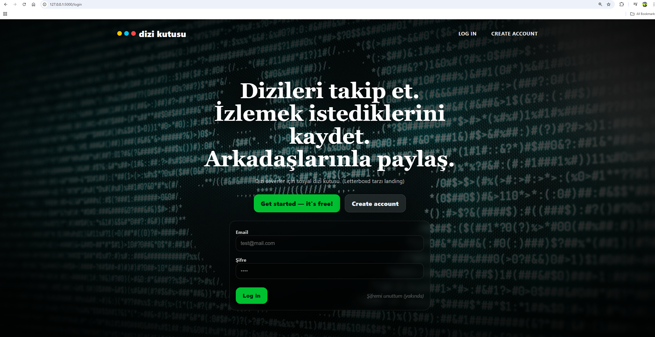

- Signup Page
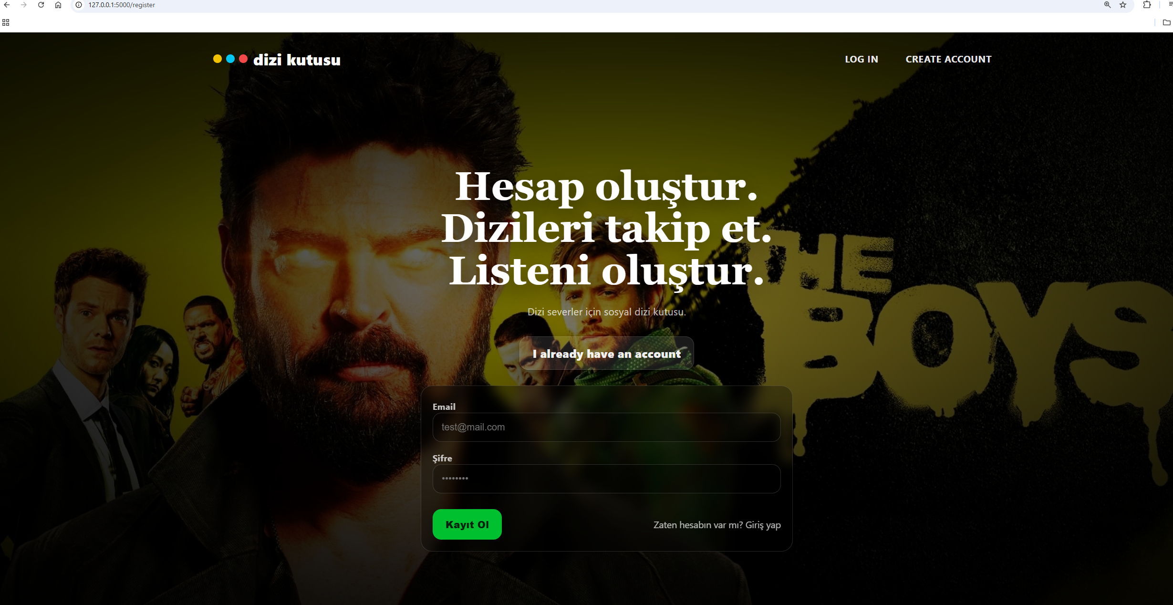

- Main Page
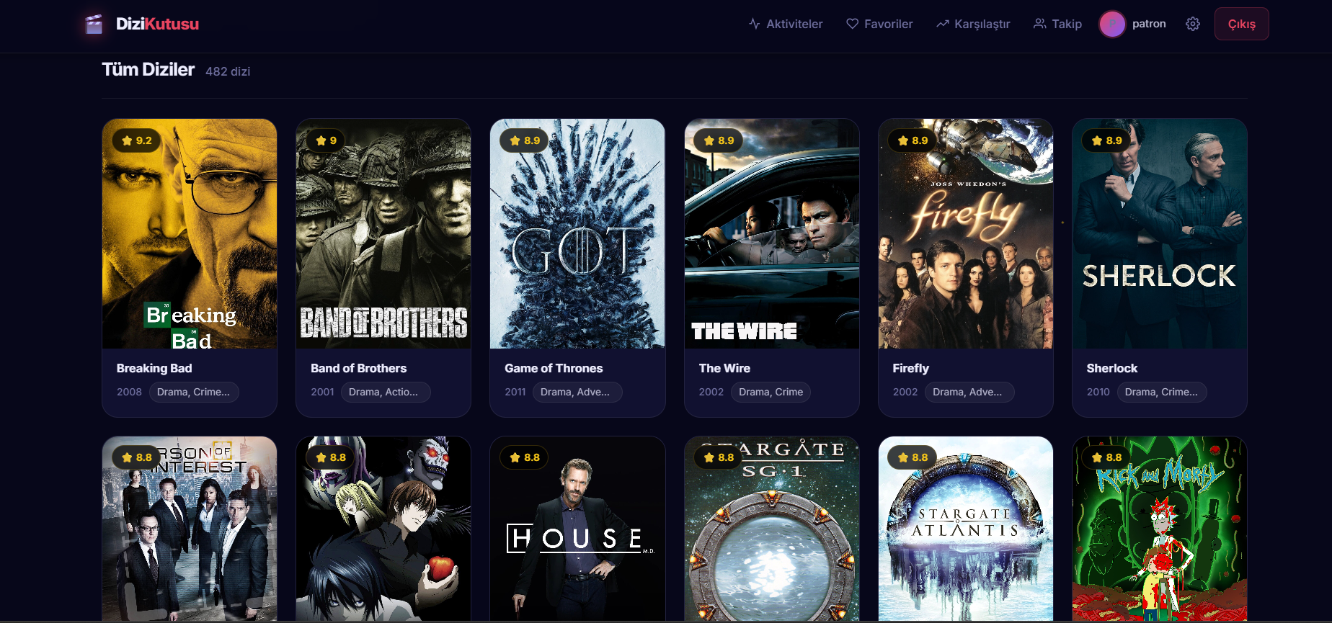
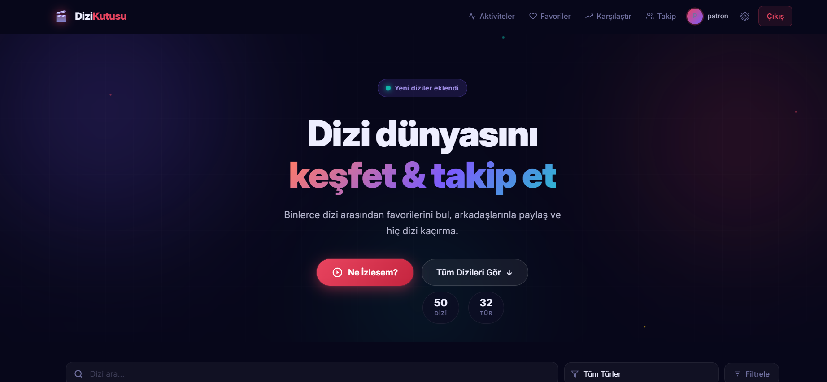

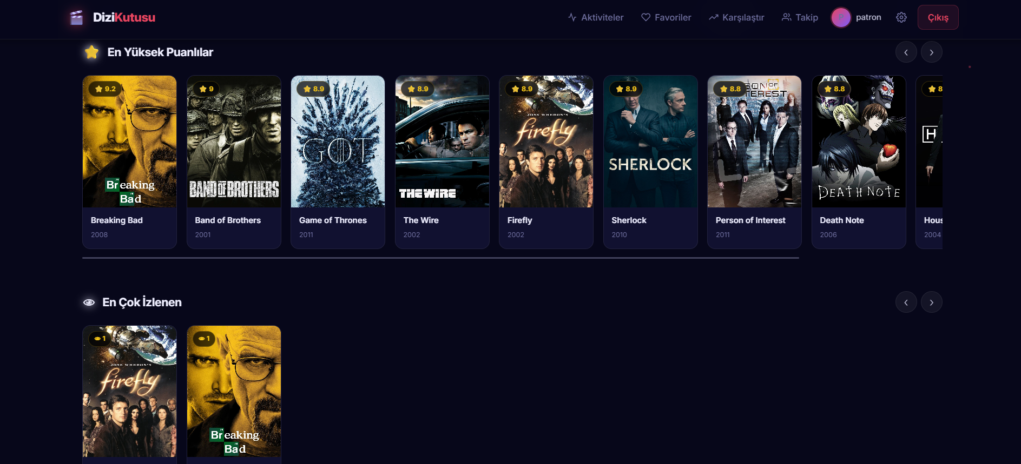

- Series Detail Page
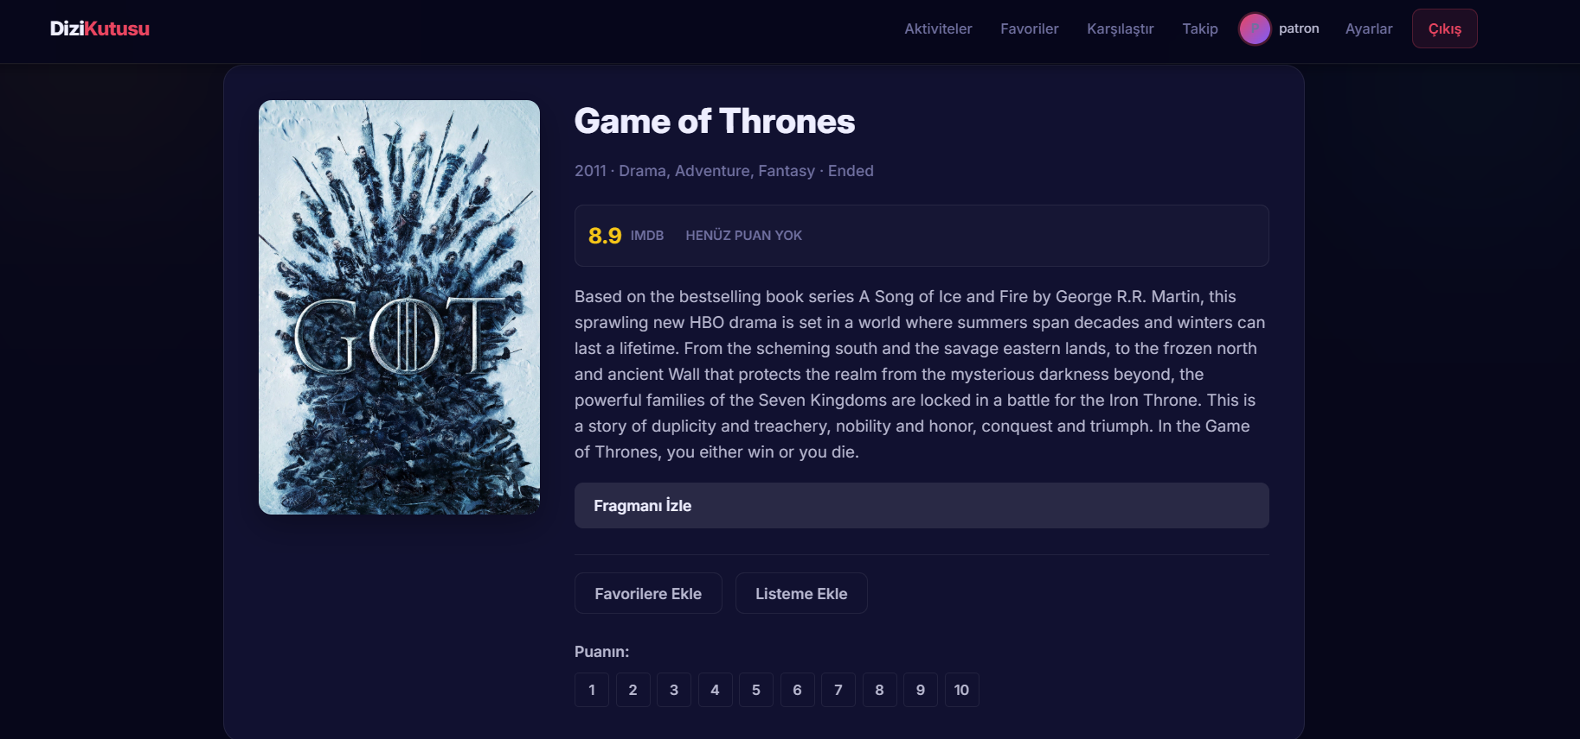

- Profile Page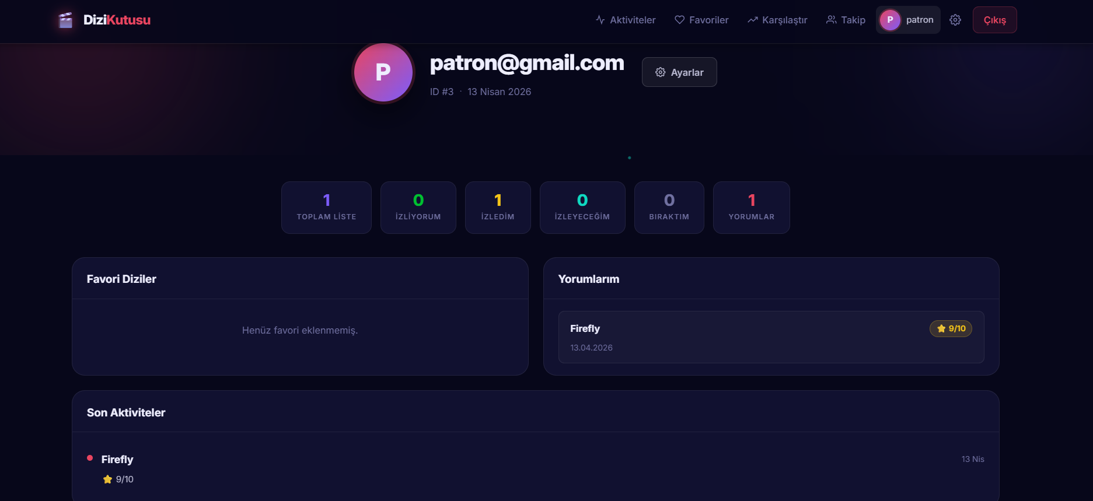
- Follow Page: 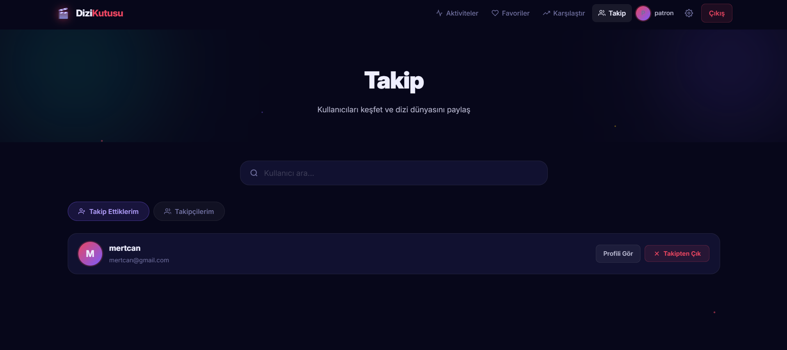

3. Use Case Support in Design

USE CASE 1 — New User Full Journey (Signup → Login → Explore)
Related Functional Requirements
- FR-1, FR-2, FR-5, FR-9
Scenario
- Kullanıcı siteye girer.
- Login denemesi başarısız olur.
- Signup sayfasına yönlendirilir.
- Kullanıcı hesap oluşturur.
- Login işlemi gerçekleştirir.
- Ana sayfaya yönlendirilir ve dizileri inceler.
Architectural Support
Presentation Layer:
- templates/auth/login.html
- templates/auth/register.html
- templates/auth/main.html
- GET /, GET /login, GET /register, GET /main
Application Layer:
- routes/main.py → root(), index()
- routes/auth.py → login(), register()
Data Layer:
- User model (app/models/user.py)
- SQLite database
Data Flow
- Kullanıcı / rotasına gider ve /login sayfasına yönlendirilir.
- Giriş başarısız olursa /register sayfasına geçer.
- Kullanıcı kayıt formunu doldurur.
- Backend duplicate kontrolü yapar ve şifreyi hash’leyerek kullanıcıyı oluşturur.
- Kullanıcı login olur ve session başlatılır.
- /main sayfasına yönlendirilir ve arayüz yüklenir.
State Changes
- Before: Kullanıcı yok, oturum yok.
- After: Kullanıcı oluşturuldu, aktif oturum başlatıldı.
Module Interaction
templates/auth/*.html
↓
routes/auth.py & routes/main.py
↓
models/user.py
↓
SQLite Database

USE CASE 2 — Search with Error Tolerance
Related Functional Requirements
- FR-9, FR-15
Scenario
- Kullanıcı arama kutusuna yanlış veya eksik bir dizi adı girer.
- Sistem benzer sonuçları döndürür.
- Kullanıcı doğru diziyi seçer.
- Dizi detay sayfası açılır.
Architectural Support
Presentation Layer:
- Global Search UI (JavaScript destekli)
- templates/series_detail.html
- GET /api/series/search?q=...
- GET /series/<id>
Application Layer:
- routes/series.py → search_series()
- routes/main.py → series_detail(series_id)
Data Layer:
- Series model (app/models/series.py)
- SQLite database
Data Flow
- Kullanıcı arama kutusuna giriş yapar.
- JavaScript ile /api/series/search?q= çağrısı yapılır.
- Backend ilike ile benzer sonuçları arar.
- JSON sonuçlar kullanıcıya gösterilir.
- Kullanıcı seçimi yapar.
- Detay sayfası render edilir.
State Changes
- Before: Arama sonucu yok.
- After: Sonuçlar listelendi ve seçilen dizi görüntülendi.
Module Interaction
Search UI / templates/series_detail.html
↓
routes/series.py & routes/main.py
↓
models/series.py
↓
SQLite Database

USE CASE 3 — Watch → Rate → Review Flow
Related Functional Requirements
- FR-17, FR-18, FR-22
Scenario
- Kullanıcı bir diziyi seçer.
- İzleme listesine ekler.
- İzleme durumunu “completed” olarak günceller.
- Diziye 1–10 arasında puan verir.
- Yorum yazar ve kaydeder.
Architectural Support
Presentation Layer:
- templates/series_detail.html
- POST /api/watchlist/<id>
- PUT /api/watchlist/<id>/status
- POST /api/series/<id>/rate
- POST /api/series/<id>/comments
Application Layer:
- routes/watchlist.py → add_to_watchlist(), update_status()
- routes/series.py → rate_series(), add_comment()
Data Layer:
- Watchlist, Review, Series modelleri
- SQLite database
Data Flow
- Kullanıcı “Listeme Ekle” butonuna basar.
- Watchlist endpoint’ine POST isteği gönderilir.
- Kullanıcı durumunu “completed” yapar.
- Puan seçildiğinde backend’e gönderilir.
- Yorum gönderilir ve veritabanına kaydedilir.
- Ortalama puan güncellenir ve frontend’e yansıtılır.
State Changes
- Before: Watchlist, puan ve yorum yok.
- After: Watchlist kaydı oluşturuldu, yorum eklendi, puan güncellendi.
Module Interaction
templates/series_detail.html
↓
routes/watchlist.py & routes/series.py
↓
models/watchlist.py, models/review.py, models/series.py
↓
SQLite Database

USE CASE 4 — Social Interaction Flow
Related Functional Requirements
- FR-27, FR-29, FR-31
Scenario
- Kullanıcı başka bir kullanıcıyı arar.
- Takip eder.
- Profiline girer ve izleme listesini görüntüler.
- Aktivite feed’inde son hareketleri görür.
Architectural Support
Presentation Layer:
- templates/friends.html
- templates/friend_profile.html
- templates/feed.html
- POST /api/friendships/<id>
- GET /api/friendships/user/<id>/watchlist
Application Layer:
- routes/friendship.py → search_users(), follow_user_short(), get_friend_watchlist()
- routes/main.py → friend_profile(), feed()
Data Layer:
- User, Friendship, Watchlist, Review modelleri
- SQLite database
Data Flow
- Kullanıcı arama yapar ve takip isteği gönderir.
- Takip ilişkisi veritabanına kaydedilir.
- Profil sayfasına gidilir ve watchlist yüklenir.
- Feed sayfasında arkadaş aktiviteleri gösterilir.
State Changes
- Before: Takip ilişkisi yok.
- After: Takip ilişkisi oluşturuldu ve feed güncellendi.
Module Interaction
templates/friends.html / templates/friend_profile.html / templates/feed.html
↓
routes/friendship.py & routes/main.py
↓
models/friendship.py, models/user.py, models/watchlist.py, models/review.py
↓
SQLite Database

Architecture Summary for All Use Cases
All 4 use cases follow:
Presentation Layer
→ Route Layer
→ Service Layer
→ Model Layer
→ Database
This ensures:
- Separation of concerns
- Testability
- Modularity
- Maintainability

4. Design Decisions
Technology Comparison
Flask vs Django
Feature | Flask | Django
Flexibility | High | Medium
Built-in Features | Low | High
Learning curve | Easier | Hard

Decision: Flask chosen for flexibility and modular structure.

MySQL vs SQLite
Feature | MySQL | SQLite
Scalability | High | Low
Multi-user support | Yes | Limited
Setup Complexity | High | Low
Performance (small apps) | Medium | High
Decision: SQLite chosen for simplicity and ease of setup.
SQLite was selected because the project is a small to medium-scale web application. It does not require complex database configuration, making development and testing faster. SQLAlchemy is used as an ORM to manage database interactions efficiently.
5.Design Patterns and Architectural Designs
5.1 Factory Patterns
Problem:
The project requires a structured and reusable way to initialize the application, configure extensions, and register routes. If these responsibilities are handled in a single global application object, the code becomes harder to test and maintain.

Factory Pattern
Where it is Used:
The Factory Pattern is applied in the application initialization process through the create_app() function in app/__init__.py. This function is responsible for creating the Flask application instance, loading configuration settings, initializing SQLAlchemy, and registering blueprints.
Architectural Role:
The pattern is used at the application setup level. It separates object creation from object usage and allows the system to create application instances in a controlled and reusable manner.
Design Decision:
Factory Pattern was selected because the project uses a modular Flask structure and benefits from flexible application creation. It also supports easier testing by allowing separate app instances for development and test environments.
Quality Factors and Criteria:
- Maintainability: application setup logic is centralized in one place
- Testability: separate app instances can be created for automated tests
- Modularity: blueprints and extensions are registered in a clean structure
- Configurability: different configuration modes can be supported more easily

5.2 Singleton Patterns
Problem:
The project requires a shared and consistent database access object throughout the application. If multiple database manager objects were created independently in different modules, configuration and state management would become harder to maintain.
Chosen Pattern:
Singleton Pattern (framework-supported / singleton-like usage)
Where it is Used:
The project uses a shared SQLAlchemy object defined in app/db.py as:
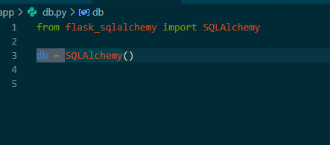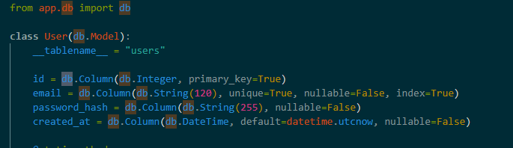
This object is imported and reused across the application modules. Due to Python’s module loading mechanism, the same db object is shared wherever it is imported. This creates singleton-like behavior, since the application works with one common database interface instead of multiple separate database objects.

Architectural Role:
This pattern appears in the data access and infrastructure layer. The shared db object acts as the central database interface for models and persistence operations.

Design Decision:
A shared database object was preferred to ensure consistency, simplify configuration, and avoid repeated initialization of database access components. Since Flask-SQLAlchemy is already designed around centralized extension initialization, this approach fits naturally into the project architecture.

Quality Factors and Criteria:
- Maintainability: database configuration is centralized in one place
- Consistency: all models and services use the same database interface
- Simplicity: avoids repeated database object creation in different modules
- Reliability: reduces the risk of configuration mismatch across components

5.3 Architectural Designs
The UML diagrams of the system were updated to reflect the integration of design patterns into the architecture.

For the Factory Pattern, an AppFactory component (create_app function) was introduced into the class diagram. Instead of directly creating the Flask application instance inside routes or tests, the system now requests an application instance from the factory. This change redirected dependencies toward the factory component, improving modularity.

For the Singleton Pattern, the shared database object (db = SQLAlchemy()) was represented as a single centralized instance in the class diagram. All models such as User and Series depend on this shared database object, which is accessed through imports. This reflects singleton-like behavior.

In the sequence diagram, object creation was updated to include the factory process. Instead of directly initializing the application, the actor (e.g., test or user request) sends a message to create_app(config). The configured application instance is returned and then used in the execution flow.

5.4 Design Decisions and Trade-offs
The design decisions were made by evaluating alternative approaches for managing application configuration and testing.
Problem:
How to run the system in both development and testing environments without affecting real data, and how to avoid hard-coded configurations.
Alternative 1:
Using a single global Flask instance with hard-coded database configuration. This approach was rejected because it reduces flexibility and makes testing difficult.
Alternative 2 (Chosen Solution):
Using the Factory Pattern through the create_app(config) function. This allows the application to be created with different configurations (e.g., test database, production database).
Decision Rationale:
Although the Factory Pattern introduces a slight increase in architectural complexity, it significantly improves flexibility and testability. It allows isolated application instances to be created for testing, preventing interference with production data.

5.5 Quality Factors and Design Pattern Impact
The selected design patterns contribute directly to key software quality attributes:
Testability:
The Factory Pattern allows the creation of separate application instances with different configurations. This enables the use of test databases and ensures that automated tests do not affect real data.

Maintainability:
The use of modular architecture (Flask Blueprints and separation of layers) improves maintainability. Changes in one module (e.g., authentication) do not affect other components.

Reusability:
Decorator-based structures (such as Flask routes and pytest fixtures) allow reusable logic across multiple parts of the application, reducing code duplication.

Performance and Resource Utilization:
The Singleton-like usage of the database object ensures that only one database interface is used across the system. This prevents redundant connections and reduces memory overhead.

6. GitHub Commit Requirement
https://github.com/mertdonmez1453/dizi-kutusu.git
All code implementations, interface definitions, and UI designs are uploaded to the GitHub repository.

Each team member contributed through commits, and version history clearly reflects individual contributions.

The repository also includes code snippets used in technology comparison and testing.

7. Task Matrix
Task | Responsible Team Member
System Overview (Description, Architecture, Tech Stack) | Şevda Yağmur Asal + Mert Dönmez
Codebase Structure & Implementation Details | Oğuz Giray Bori
Component Interfaces & API Design | Şevda Yağmur Asal
Use Case Design & Requirement Mapping | Mert Dönmez
Data Flow, State Changes & Diagrams | Oğuz Giray Bori
Design Decisions & Technology Comparison | Oğuz Giray Bori
Design Patterns (Factory, Singleton) | Şevda Yağmur Asal
Visual Interfaces (UI Screenshots / Pages) | Deren Berk
GitHub Integration & Code Organization | Mert Dönmez
Final Review & Editing | Tüm Ekip

